CS5590

**Deep Learning Programming**

**Aim:**

Implementing the Logistic regression using Tensor Flow with Deep Learning

* **Introduction**

Implementing the Logistic regression using Tensor Flow with Deep Learning

Logistic regression is a statistical method for analyzing a dataset in which there are one or more independent variables that determine an outcome. The outcome is measured with a dichotomous variable (in which there are only two possible outcomes).

* **Objectives**

Logistic Regression applied on the dataset containing the Credit score, and the current salary for predicting whether the customer leaves from the bank or want to stay in the same bank.

Goal of logistic regression to find the best fitting model to describe relationship between dichotomous characteristic of interest dependent variable = response or outcome variable and set of independent variables. Logistic regression generates the coefficients of a formula to predict a logit transformation of the probability of presence of the characteristic of interest:

ogistic regression equation

p is the probability of presence of the characteristic of interest.

The logit transformation is defined as the logged odds:

dds=p/(1-p)

ogit(p)=ln(p/(1-p))

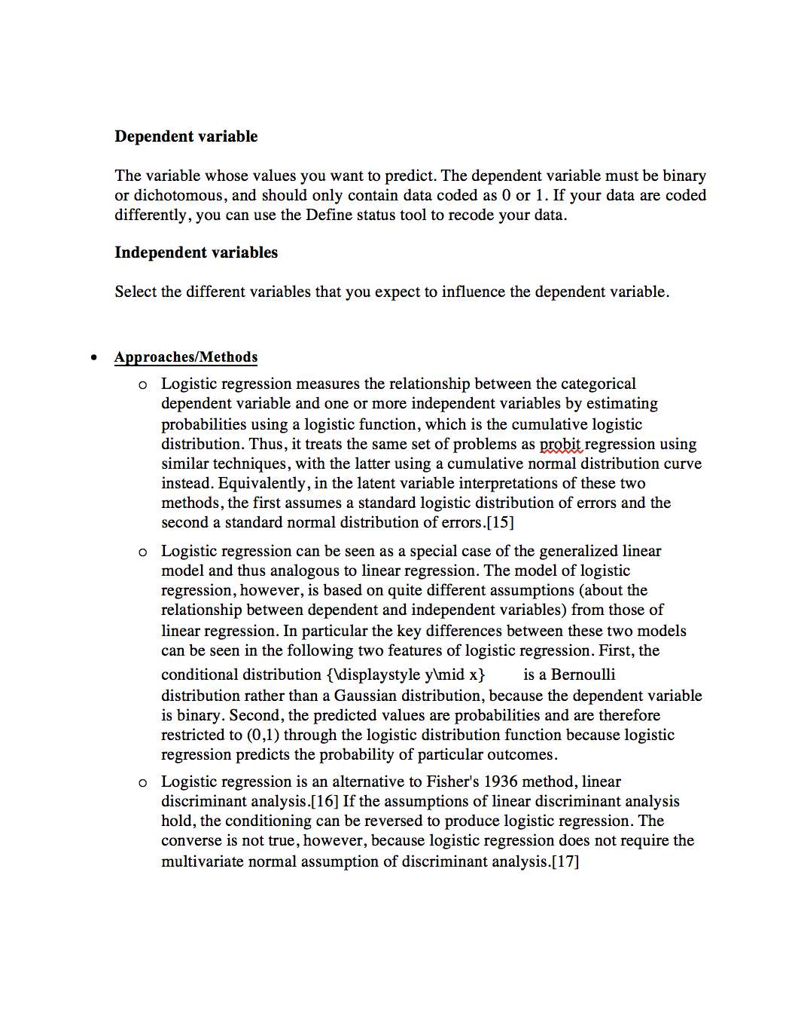

* **Workflow**

1. Frequency and Summary statistics
2. Univariate points (x1, x2, y)
3. Loading Data set
4. Slicing the data set
5. Scaling the data set for better results
6. Scatter plotting
7. Estimate model
8. Evaluate Model
9. Plotting graphs
10. Tabling results

* **Datasets**

Churn Model data set:

Which contains the data of the previous customers and their details of Credit score and etc. to predict the customer tenure in the bank

* **Evaluation & Discussion**

Performed the cross-validation approach for the model evaluation

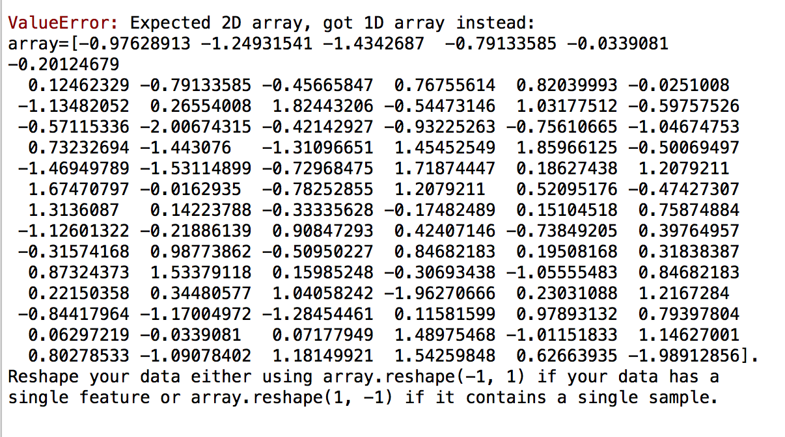

* **Conclusion**

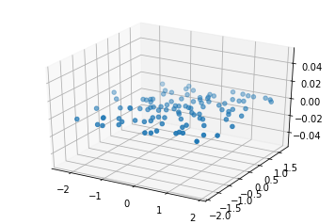

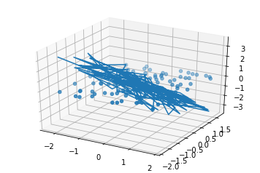



After the 50 epochs

The result with the predicted model is:

**Loss= 1.14%**